Jackie Lu

ESI4523 Project

Title: Surgical Center Optimization Case Study

The case study provides an existing Operating Room simulation in FlexSim. , you will examine the various aspects of OR modeling, with special attention paid to elements that either contribute to operational variance or make up significant portions of the OR process (and their resulting operational time changes or resources usages).

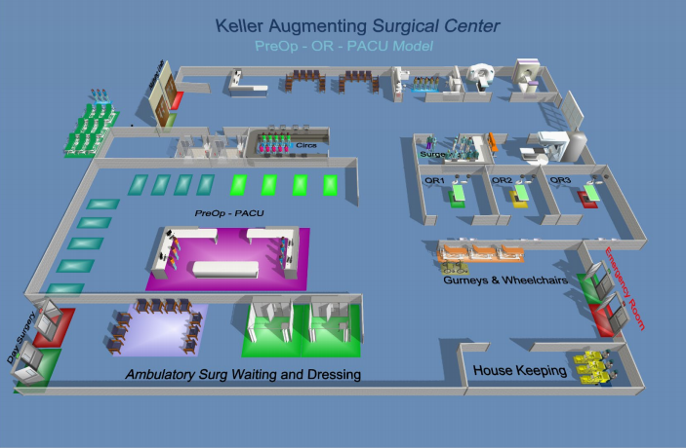

Figure . Provided Simulation Model of the Operating Room

The objective is to

1. Identify the variables your team believes are of the greatest benefit, both to the patients and to the organization that runs the OR.
2. Test different modeling scenarios to gather data that supports or rejects your assumptions.
3. Using simulation results, recommend the most effective configuration for the OR

With the definition of effective being up to interpretation. Examples of effectiveness could be revenue, utilization, or surgical cases completed. The main elements we can modify include the operating room the procedure is performed in, order of procedures, and number of staff. In our team meetings, we will go through various trials of weighing effectiveness of variables and determine which is the best configuration.